heading ~height,weight,jumping

Do anova test taking height, weight =0

Height, weight =1

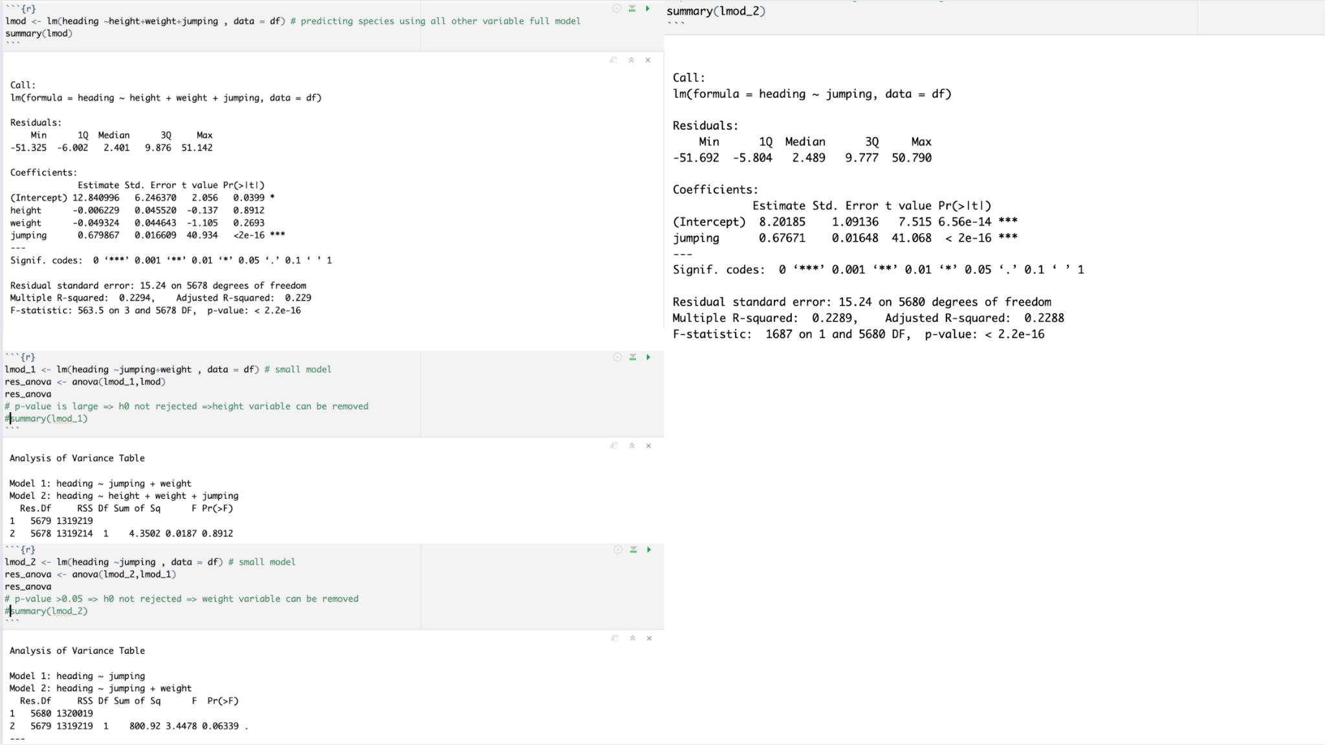

Penalties~composure, reaction, shot_power,volleys,vision,strength

Another anova test

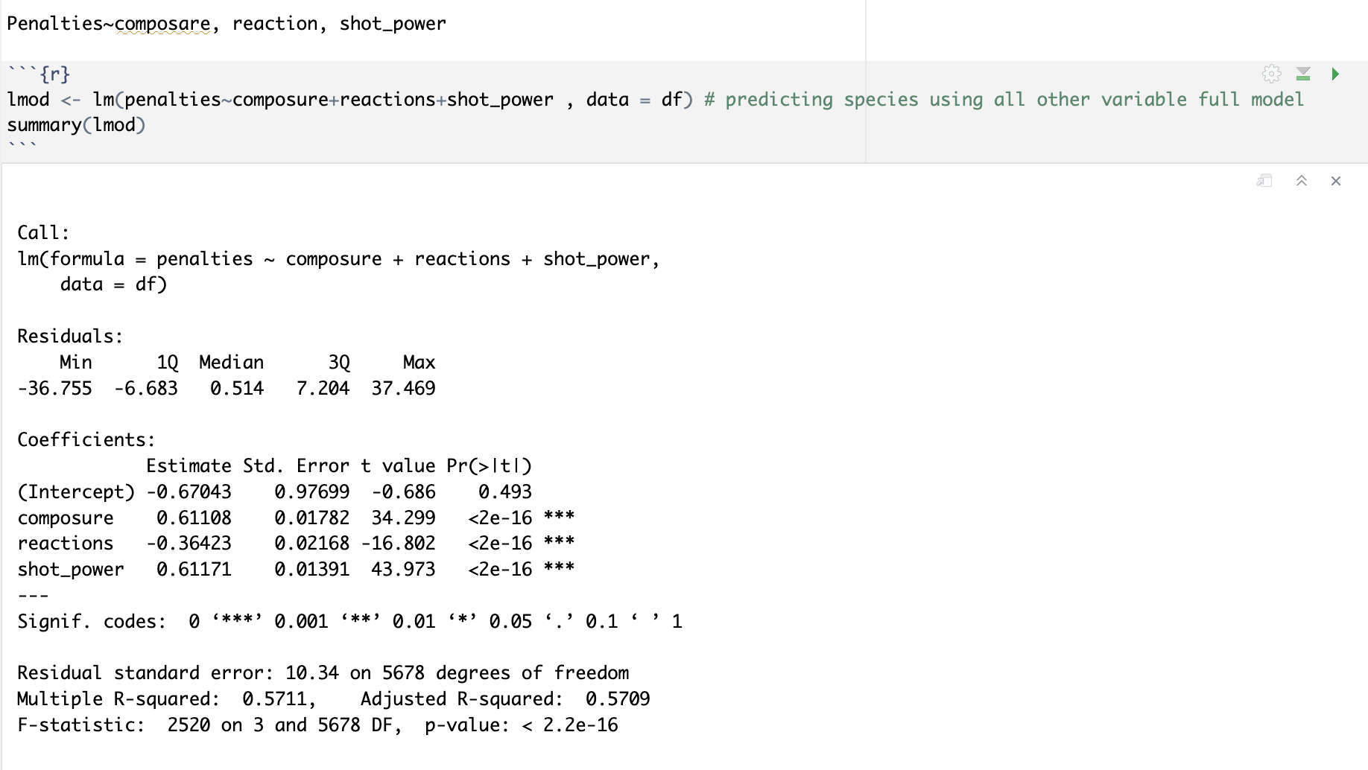

Age, player value

Ball control player value

finish

